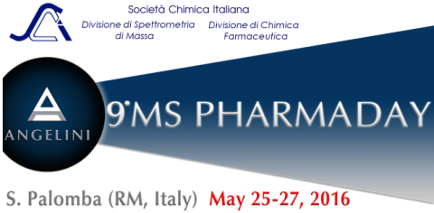

APPLICATION FORM FOR SUBMITTING A PAPER

To be sent by April 30, 2016 to | Dr.ssa Elena Demetrio  R&D – Head of Physical Chemistry Laboratory - ANGELINI | S. PALOMBA  Acraf S.p.A. – Piazzale della Stazione, snc – 00040 S. Palomba – Pomezia (RM) - Italia    +39 0691045371   e.demetrio@angelini.it

Presenting Author

Name and Surname

Organization
Address |  | Zip code – Town – Country
Telephone | Fax | E-mail

Preference:  Oral presentation  Poster

Title

Authors
Organization(s)

TITLE OF THE PAPER (TIMES NEW ROMAN, CAPITAL,
BOLD, 14 PT, SINGLE SPACE)
(2 lines spacing)

Name of Authors
(Times New Roman, italic, 12 pt, exact spacing 14 pt)
(2 lines spacing)

Affiliation
(Times New Roman, 10 pt, exact spacing 12 pt)
(2 lines spacing)

Text (Times New Roman, 12 pt, single spacing, justified) xxx xxxx xxxx xxxx xxxx xxx xxxx xxxxx xx xxx xxx xxxxx xxxx xxx xxxx xxxx xxxxx xx xxxx xx xxxxxx xxx xxx xxxx xxx xxx xx xxxxx xxxxxxxx xx xxxx xxx xx xxxxxx xx xxx
xxx xxxx xxxx xxxx xxxx xxx xxxx xxxxx xx xxx xxx xxxxx xxxx xxx xxxx xxxx xxxxx xx xxxx xx xxxxxx xxx xxx xxxx xxx xxx xx xxxxx xxxxxxxx xx xxxx xxx xx xxxxxx xx xxx xxxxxx xx

Reference Times New Roman 10 pts. Journal title in italics. Paper title is not requested.
T. Surname1, P. Surname2, Journal, vol, pages (year)

PLEASE, DO NOT EXCEED TWO PAGES

