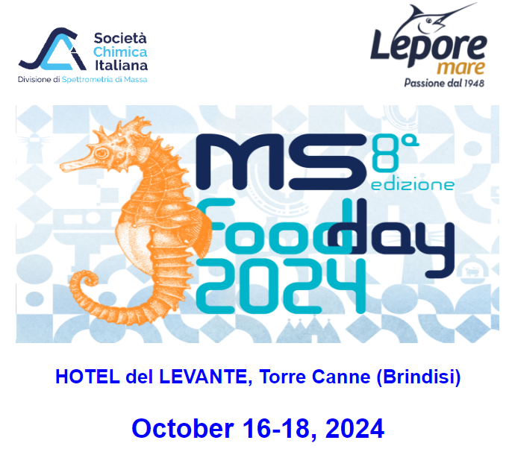

LATE ABSTRACT SUBMISSION FORM

To be sent by September 5th, 2024 to

https://www.spettrometriadimassa.it/Congressi/8MS-FoodDay/8MSFoodDay_SubmissionForm.php

Presenting Author

Surname and name

Company or Organization
Address |  | Zip code – Town – Country
Telephone | Fax | E-mail
Poster presentation

Title

Authors
Company(es) or Organization(s)
Title in Times New Roman Bold 14 pts centered

Authors in times new roman 12pts¹ centered

¹ affiliation times new roman 10pts centered

Summary: Maximum 50 words Times New Roman Italics 11pts

Keywords: introduce maximum 3 keywords defining the topics of your abstract

1 Section titles 12 pts bold

(e.g.: Introduction, Experimental, Results, Conclusions)
Main body in two columns. Text 11 pts justified.
Place formulas along with the text left aligned.
Place figures either in line with the text or across the two columns. Figures should be centered and images have to be reported with a resolution close to 300 dpi.
Fig. 1. figure caption italics 10 pts..
Place tables either in line with the text. Tables should be centered. Place table caption before the table

Table 1. table caption italics 10 pts
Features | ^{Standard farming} | ^{Biological farming}
Integral of the response | 100% | 7%
Steady-state signal shift | 96.78% | 42.8%
Integral + Shift of Fequency | 93.54% | 42.8%

References
List reference quoted sequentially in the text and marked as [1]. Reference text 10 pts. Journal title in italics. Paper title is not requested.

T. Eklov, P. Mårtensson, I. Lundstrom; Analytica Chimica Acta, 381 (1991), pp 221-232.
- F. Takens, D. Rand and L.S. Young editors, Dynamical Systems and Turbulence, Warwick 1980, pp 36-38.

DO NOT EXCEED TWO PAGES

